Here are some questions drawing on the skills needed for Paper 2 on Algorithms, Programming and Logic. Print this out and either scan or photograph to return to me for marking.

Once you have completed Level 2, move on to Level 3.

1 Which statement?

Tick the appropriate column to indicate whether the statement is an assignment, selection, or iteration statement.

|  |  |  |  |
| --- | --- | --- | --- |
| Statement | Assignment | Selection | Iteration |
| IF Number1 > Number2 |  |  |  |
| Number1 <- Number2 |  |  |  |
| Number1 <- Number2 + 1 |  |  |  |
| FOR Number1 <- 1 TO 10 |  |  |  |
| CASE OF Number1 |  |  |  |
| WHILE Number1 <> Number2 |  |  |  |
| REPEAT |  |  |  |

[3]

2 Pseudocode Algorithm

This algorithm checks to see if the password is correct, it should allow the user to try three times.

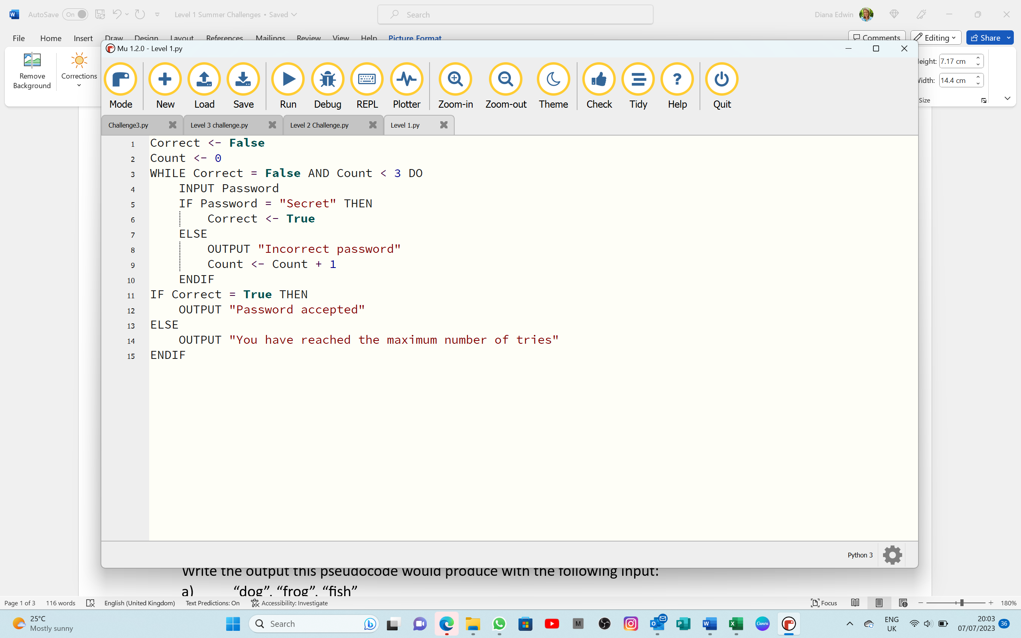

Write the output this pseudocode would produce with the following input:   
a) “dog”, “frog”, “fish”

|  |
| --- |
|  |
|  |
|  |
|  |
| [3] |

b) “Mystery”, “Secret”

|  |
| --- |
|  |
|  |
|  |
|  |
| [2] |

c) Rewrite this pseudocode in Python (use Grok or a Python editor to do this if you wish,   
then copy in here)

|  |
| --- |
|  |
|  |
|  |
|  |
|  |
|  |
|  |
|  |
|  |
|  |
|  |
|  |
|  |
|  |
|  |
| [8] |

3 Use a variable called Counter in PSEUDOCODE to print “This message will self-destruct in 10 seconds”, then the numbers 10 down to 1 and then the word “Boom!”

*[Hint: this only requires 4 lines of code]*

|  |
| --- |
|  |
|  |
|  |
|  |
|  |
|  |
| [4] |